World History
Mt2- Imperialism and Industrialization
Level 3 Project

Due date: December 8th, 2016 @3:45 on Google Classroom
Assignment: You will review the information you learned in Measurement topic #2 (Imperialism and Industrialization) and research information about one country that was Imperialized.
1st-Review what made it possible for England to be the first nation to industrialize
2nd-Review the basics of capitalism and Communism
3rd-****Research one nation that was imperialized*****
Period 2- South Africa
Period 3-India
Period 4-Vietnam or Laos
Period 5-Philippines
Period7-Congo
----Name of the nation imperialized (taken over), Who imperialized them? When were they imperialized? Why was
the nation imperialized, for what reasons? How was the imperialized (taken over nation) treated? (details!)
*** One citations need to be from your own research***

Requirements for different projects
Power point – Must have a title page, 7 slides of information & one picture on each slide, and a work cited page with 3 citations=9 slides
Research paper – Must be 3 full pages typed and have a work cited page with 3 citations
Brochure – Must have title page, inside information laid out in an organized fashion, have pictures/graphs and have 3 citations on the back
Newsletter- Front and back, must have 3-4 articles and pictures and 3 citations on the back page
Or any other type of evidence that has been approved by Ms. Torres

Due date: December 8th, 2016 @3:45 on Google Classroom
Due date Protocol
If you need an extension: You need to notify Ms. Torres two days in advance.
If project is turned in late: Any student that does not complete the mt project at level 3 proficiency by the due date will complete the 5 page in class essay for the MT in place of the project and your life skills grade will be affected.
Resources:
Information regarding MT2: www.torreslhs.weebly.com
How to cite: http://www.easybib.com

Assessment Rubric for PowerPoint Presentations
 | Exemplary 3 | Developing 2 | Beginning 1
Organization | Information presented in logical, interesting sequence | Information in logical sequence at times. | Difficult to follow presentation--student jumps around
Subject Knowledge | Demonstrates full knowledge by answering all learning targets with explanations and elaborations | At ease with expected answers to questions but does not elaborate, go into detail. | Uncomfortable with information and is able to answer only rudimentary questions
Graphics | Explain and reinforce screen text and presentation | At times is related to text and presentation | Rarely uses graphics that support text and presentation

Notes for how to cite:
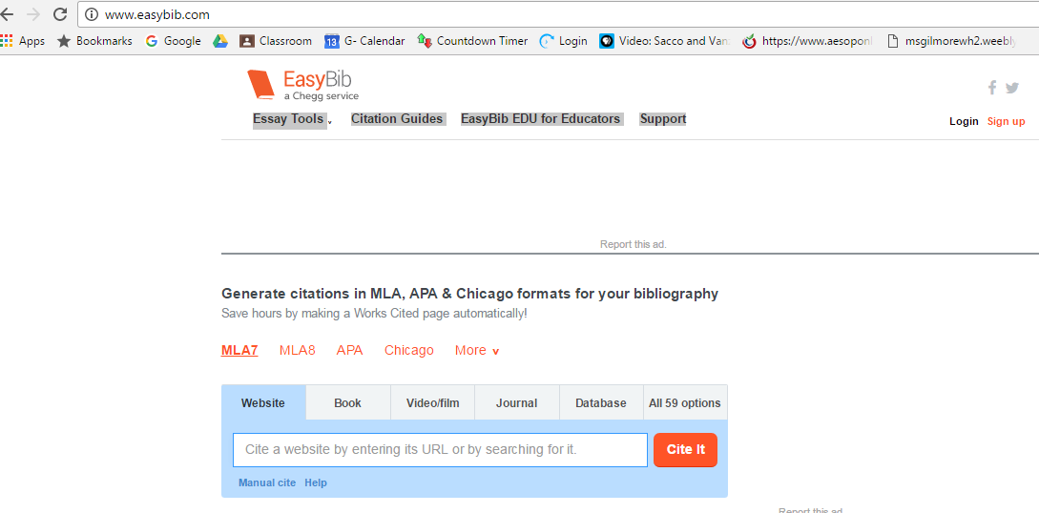

Examples:
If you use a book:
Spielvogel, Jackson S. "Chapter 4 Section 4." World History - California Edition: Modern times. S.l.: Glencoe Mcgraw-Hill Schoo, 2006. 75-78. Print.
If you use a website:
History.com Staff. "Spanish American War." History.com. A&E Television Networks, 2010. Web. 07 Oct. 2016.
If you use my handouts:
Torres, Christina, Ms. MT1: The Development of Modern Political Thought LT#2 Who Were Some Important Leaders of the Enlightenment Movement and What Were Some of Their Ideas? Handout #3. Lindsay CA: LHS, 2016. Print.
Torres, Christina, Ms. MT1: THe Development of Modern Political Thought LT1&2 Explain the Connection between the Magna Carta, English Bill of Rights, Locke's, Montesquieu's and Rousseau's Ideas to the American Revolution and the New American Government. Handout #4. Lindsay CA: LHS, 2016. Print.

