MT2 Lt#1 Handout #1 Name: Block: Date:
World History
Measurement Topic 2: Industrial Expansion & Imperialism

Learning target #1: Why was England the first country to industrialize?

Directions: The following questions are based on the accompanying documents /graphs /maps /quotes. As you read and analyze (think about) each document/graph/map/quote be sure to:
1st- Number the paragraphs
2nd- Independently read the passage, and circle words you don't know. Predict the meaning of the words.
3rd- Read the passage a second time with a partner, highlight information and write side notes.
4th- Answer the questions on the back in complete sentences.

Document 1- Map of England natural resources

England­
resources and canals­
circa 1700
Document 1

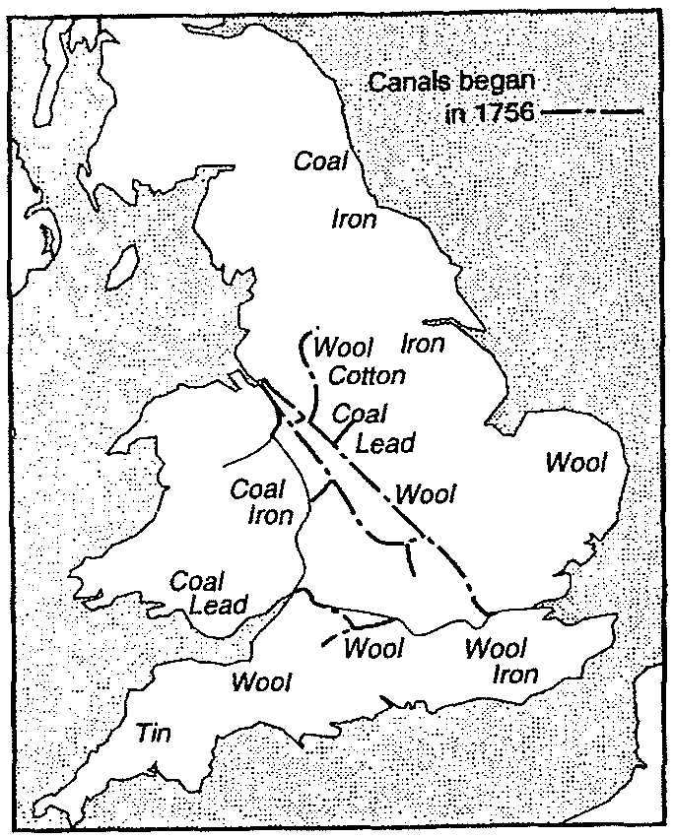1. According to the map, what resources did England have that were needed for industrialization?

Document 2- Passage comes from "Landmarks in England Industrial History" a book written by George Warner in 1899

England...has been fortunate in possessing the natural conditions necessary to success.... we recognize that England is rich in these (natural) advantages, that she (England) has coal and iron lying close together, that her sheep give the best wool, that her harbors are plentiful, that she is not ill-off for rivers, and that no part of the country is farther than seventy miles from the sea.

2. How did the natural resources in England help England Industrialize?

Document 3- Graphic showing different methods of manufacturing
Source: Encarta Online Encyclopedia
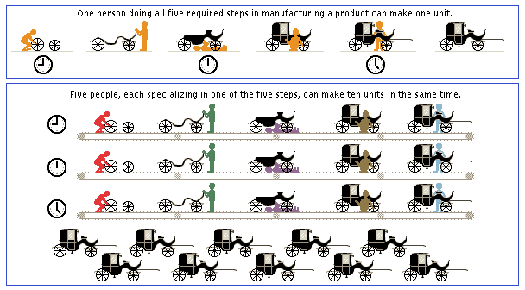
Example A

Example B

3. What are the two examples comparing? Describe what is going on in each example.

4. If you were an English business owner during the start of the industrial revolution, which system would you use and why?

Document 4- Chart on new inventions in textile industry {clothing making business)

Changes in textile machinery
Inventor | Invention | Importance | Effect
John kay | Flying shuttle | Increased the speed of weaving | Cloth made faster
James  Hargreaves | Spinning Jenny | Spun 8-10 at a time/used at home | People could spin thread much faster
Richard  Arkwright | Water frame | Large spinning machine powered  by water in a factory | Spun thread faster using water power not  people power= cloth made very fast
Edward  Cartwright | Power loom | Water powered. Wove thread into cloth | spinning could be powered by water resulting in more cloth produced/made/created
Eli Whitney | Cotton gin | Separated seed from cotton | Cleaner cotton = more cotton

5. Which of these three inventions were most important in increasing textile (cloth) production? Explain your answer.

Using the information found in your power point notes, handout #1 and your knowledge regarding how England became industrialized, write one page essay explaining how England was able to become the first nation to industrialize.

Be sure to add evidence from one of the four documents (DBQ) above to your essay.

