World History
Measurement Topic 2: Industrial Expansion & Imperialism

Learning target #1: Why was England the first country to industrialize?
Directions:
1st- Number the paragraphs
2nd - Independently read the passage, and circle words you don’t know. Predict the meaning of the words.
3rd- Read the passage a second time with a partner, highlight information and write side notes.
4th- Answer the questions on the back in complete sentences.

In the 1900’s many nations began to change from agricultural based to more industrial. Most families would produce/make what they needed at home, very rarely purchasing/buying things from others. England was one of the first nations to go from being agricultural based to industrialized. Industrialization is when a nation uses natural resources (things found in nature/not man made) and turns them into different products. This process is usually done large scale, in a factory, quickly and much cheaper than any that could be done at home or by a single person. England was the first nation to industrialize for many different reasons. They had plenty of food, their population had increased, they had plenty of capital/money to use/ plenty of natural resources, a stable government and markets/or places to sell their finished products.

For many years people had farmed small areas of land near their homes for their families. If they had any extra food they would store it for times when food was scarce or they would sell what little they had left for other goods they needed. However in the early 1800 better farming techniques were created which resulted in larger quantities of foods being produced. Peoples fear of dying from starvation decreased. A new crop, the potato, also helped to increase the food supply. Between the better farming techniques and the new crop, the potato, England hand plenty of food to supply its population.

As a result of the increasing in food, the population in England also increased. People felt stable enough to have larger families and not worry about their children or themselves starving. This increase in population led to many people who needed to work, since farming techniques were so efficient less people were need to work on the farms so people moved to towns find work.

In the 1800’s new inventions were created which help create products faster; the spinning Jenny, cotton gin, and the steam engine. These inventions turned making cotton to clothing from a long process into an extremely quick process. Something that once took days or weeks to be completed could be done in a matter of minutes or hours. Entrepreneurs, people with capital/money, wanted to invest their money into these new inventions to produce more money. Entrepreneurs would buy the land, inventions, build the factories, buy the nature resources, and hire the workers who would then create products such as clothing to sell all around the world. These Entrepreneurs developed into business owners and they became very wealthy from their business. New inventions were constantly being created to help improve this process.

England also had the supply of natural resources to help them be the first nation to industrialize and turn from being just agrarian (farming) based to more industrialized. England had many of large navigable/passable rivers. Factories were built near rivers for their water supply for the steam engines (energy to run the factories/machines) and also to transport the natural resources to the factories and the finished products to sea ports and out to other nations. England had a large supply of coal, a rock that is mined from the ground that was used as fuel to warm the water to run the steam engines. England also had a large supply of iron which was used to build the large factories. These natural resources allowed England to industrialize very quickly.

England was also the first nation to industrialize because they had a very stable government, unlike other nations. England’s government allowed Entrepreneurs to invest their money how they wanted, run their business with very little interference from the government, so most people with any capital/money were willing to invest in factories knowing their government would support them.

England also had a vast empire around the world. England had set up colonies, places it controlled outside of England, all around the world. As a result of this vast empire, as well as the fact that England (Britain) had the best navy in the world, England had the ability above all the other nations to ship their finished products to markets (stores/places) all over the world. Also due to the population growth in England and the fact that more people were working, the population in England was also purchasing more products because they had the capital as well to purchase goods not have to create them at home.

As a result of England having markets, a stable government, natural resources, capital, the population and the food supply they were the first nation in the world to become industrialized.

Directions: Answer the following questions after you have read and highlighted the above passage.
- What were the six things that contributed to Great Britain being the first to industrialize?

- Why is capital important when industrializing?

- Why was an increase in the food supply important to industrializing?

- What function do people play when a country wants to industrialize?

- What natural resources helped England industrialized and how did it help?

- Who would England sell their products too?

- Write a summary explaining how Great Britain(England) was able to industrialize (5 sentences)

World History
Measurement Topic 2: Industrial Expansion & Imperialism

Learning target #1: Why was England the first country to industrialize?

Directions: The following questions are based on the accompanying documents /graphs /maps /quotes. As you read and analyze (think about) each document/graph/map/quote be sure to:
1st- Number the paragraphs
2nd- Independently read the passage, and circle words you don't know. Predict the meaning of the words.
3rd- Read the passage a second time with a partner, highlight information and write side notes.
4th- Answer the questions on the back in complete sentences.

Document 1- Map of England natural resources

England­
resources and canals­
circa 1700
Document 1

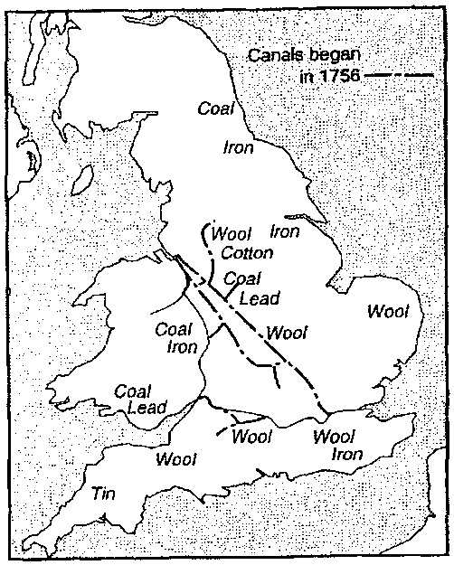
1. According to the map, what resources did England have that were needed for industrialization?

Document 2- Passage comes from "Landmarks in England Industrial History" a book written by George Warner in 1899

England...has been fortunate in possessing the natural conditions necessary to success.... we recognize that England is rich in these (natural) advantages,that she has coal and iron lying close together,that her sheep give the best wool,that her harbors are plentiful,that she is not ill-off for rivers,and that no part of the country is farther than seventy miles from the sea.

2. How did the natural resources in England help England Industrialize?

Document 3- Chart on Inventions that improved agriculture

Changes in agriculture
Inventor | Invention | Importance
Jethro Tull | Horse-drawn seed drill | Planted seeds in straight rows to get more crops from one row
Robert Blackewell | stock breeding | improved quality of animals to produce more meat, milk and wool
Cyrus McCormick | Mechanical reaper | Made harvesting/gathering grain easier, faster and cheaper

3. What was the result of these changes in agriculture in England?

Document 4- Chart on new inventions in textile industry {clothing making business)

Changes in textile machinery
Inventor | Invention | Importance | Effect
John kay | Flying shuttle | Increased the speed of weaving | Cloth made faster
James  Hargreaves | Spinning Jenny | Spun 8-10 at a time/used at home | People could spin thread much faster
Richard  Arkwright | Water frame | Large spinning machine powered  by water in a factory | Spun thread faster using water power not  people power= cloth made very fast
Edward  Cartwright | Power loom | Water powered. Wove thread into cloth | spinning could be powered by water resulting in more cloth produced/made/created
Eli Whitney | Cotton gin | Separated seed from cotton | Cleaner cotton = more cot

4. Which of these three inventions were most important in increasing textile production? Explain your answer.

Using the information on this document and the power point Mt2 LT1 on how England becoming industrialized, write one page essay explaining what allowed England to be the first nation to industrialize.

Be sure to add evidence from one of the four documents in handout #1 in your Essay
Do this on a separate sheet of paper and staple to this handout.

