World History
Measurement Topic 2: Industrial Expansion & Imperialism
Learning Target #3: Why did the new nations who industrialized begin to imperialize other nations?
Directions:
1st- Number the paragraphs
2nd - Independently read the passage, and circle words you don’t know. Predict the meaning of the words.
3rd- Read the passage a second time with a partner, highlight information and write side notes.
4th- Answer the questions on the back in complete sentences.

England became the first country to industrialize because it had an abundance of food to feed the people, a large population to provide labor, the natural resources such as water and coal to provide transportation and or fuel, they had investors who used their capital to build the factories, markets around the world to sell their finished products and an army to protect all the products being shipped to the different parts of the world. England’s success with industrialization created a new economic system called capitalism. (Utopianism, Communism were responses to capitalism)
Other countries began to follow England and they created their own industrial economies, making money by producing goods and selling the products. Spain, Portugal, Germany, Italy, Belgium, Netherlands, France and many more countries began to industrialize. These countries needed natural resources, people, land and capital to be successful at industrialization, but not all of them had those things which led to Imperialism.
Imperialism is when a powerful country takes over another area that is not in its country. The more powerful country would take over the land, the government, the resources, and the people. Some powerful countries dominated by controlling the land, resources and people, while others worked with the current government/people to, but this did not happen often.

Why did countries/nations participate in imperialism?
1st: Natural resources. Powerful countries that wanted to follow the success of England needed natural resources to help them become successful at industrialization. These nations needed coal, oil, timber/wood, cotton, and other resources to create their products. The powerful nations also needed labors/people to grow, harvest, gather, the natural resources and colonies (areas that had been imperialized) provided cheap or free labors. The powerful nations also need new markets, a place to sell their finished products, such as (clothing made from cotton, tools made from iron, furniture made from wood) and the colonies provided these new markets.
2nd: Nationalism. Nationalism is to have loyalty and pride in one’s country. During the time of industrialization and imperialism people wanted their nations to be the best. The best nations had colonies; only weak nations did not own colonies, so it was seen as a necessity to have colonies so that a nation would not be seen as weak. Powerful nations wanted to have the best advantage possible over their rivals and the more colonies a nation had the better advantage they had.
3rd: Social Darwinism, the idea created by Charles Darwin that only best, smartest, strongest survives, was an important part of nationalism because people saw themselves as the best, smartest and strongest therefore all the weaker areas of the world were supposed to be taken over and dominated. Social Darwinism made it ok to forcefully take over weaker nations. European nations saw all other cultures and races as inferior therefore they needed to be dominated and used. Social Darwinism also made it ok to say that some races were better than other races, which increased racial inequalities, differences between races.
4th: National Security. Imperialism was seen as ok because colonies needed to be protected. Natural resources, markets and trading areas needed to be protected; therefore nations began building up their armies to protect their colonies. Powerful nations would also take over large areas of land near their colonies just to protect their main colonies. European nations also sought strategic territory to ensure access for their navies and armies around the world to provide easy access for their markets.
5th: Christianization Some Europeans wanted to help the people in the imperialized countries. They felt it was their duty, “White Man’s Burden”, to help the primitive, uneducated, wild people. The missionaries (Christian people who wanted to save the heathens) saw themselves as heroes going in and teaching the wild heathens about Christianity, better governments, capitalism and educating them. Europeans believed they were doing the right thing by going in and making the people change to Christianity, change their governments and/or change their way of life to be more “normal”. Missionaries built churches, required the natives to attend and eventually to convert/change to being Christians. Missionaries built schools and required children to learn their language, wear clothing and behave more European.
England, France, Portugal, Spain, Italy, Germany, Belgium, Netherlands, and Holland all began to imperialize/ colonize different parts of the world, but they all fought over Africa. To keep the powerful countries from going to war a meeting was held in Berlin, Germany. This meeting was known as the Berlin conference and Africa was divided up between all the powerful European nations. No African nations/kings/or representatives were at the conference when their land was divided up.
Industrialization led many European nations to develop industrialized economies resulting in imperialism to gain natural resources, and lead to nationalism with the idea of social Darwinism, national security to protect the colonies and missionaries who Christianized and changed the colonized people.

Directions: Use your PowerPoint notes and the handout to answer the following questions.
- What is imperialism?

- Why did nations colonize new areas? Why or for what reasons did nations practice imperialism? Why did Europeans countries need to colonize?

- Explain the idea of nationalism.

- Why was national security important in imperialism?

- What is Social Darwinism? Details.

- Who were missionaries? Why did they want to participate in imperialism/creating colonies?

- What was “white man’s burden”?

World History
Measurement Topic 2: Industrial Expansion & Imperialism

Learning target #3: Which European countries developed industrial economies and why did the new industrial nations imperialize and colonialize?
Directions: The following questions are based on the accompanying documents/graphs/maps/quotes. As you read and analyze (think about) each document/graph/map/quote be sure to:
1st- Read the passage independently or with a partner, highlight information and write side notes.
2nd - Answer the questions in complete sentences using the document as evidence.

Document #1
Source: Cecil Rhodes, Confession of Faith, originally written at Oxford, 1877 (adapted)
I contend that we [English] are the finest race in the world, and the more of the world we inhabit, the better it is for the human race. . . . It is our duty to seize every opportunity of acquiring more territory and we should keep this one idea steadily before our eyes that more territory simply means more of the Anglo-Saxon race [white], more of the best, the most human, most honourable race the world possesses.
- Identify three key beliefs of Rhodes.

- According to Rhodes, why should Britain pursue a policy of imperialism?

Document #2
Source: William L. Langer, The Diplomacy of Imperialism, Knopf, 1935 (adapted)
But the economic side . . . must not be allowed to obscure [hide] the other factors. Psychologically speaking, . . . evolutionary teaching [about the “survival of the fittest”] was perhaps most crucial. “Survival of the fittest” … justified competition and struggle but introduced an element of ruthlessness. . . .
- According to Langer, what was the noneconomic reason for the new imperialism?

Document #3
Source: Bishop Desmond Tutu, 1984 South Africa Sunday Times, November 26, 2000
When the missionaries came to Africa they had the Bible and we had the land. They said ‘Let us pray’. We closed our eyes. When we opened them, we had the Bible and they had the land.— Bishop Desmond Tutu, 1984 Source: South Africa Sunday Times, November 26, 2000
- Restate the main idea of this passage

- According to Bishop Desmond, what was the true purpose of the missionaries in Africa?
Document #4
Map a: Map of Africa before Imperialism/colonization Map b: This map details European Imperialism in Africa in 1914.
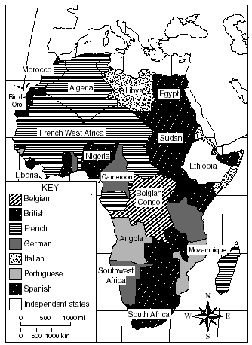
Each different color represents tribes/ Empires of Africa.
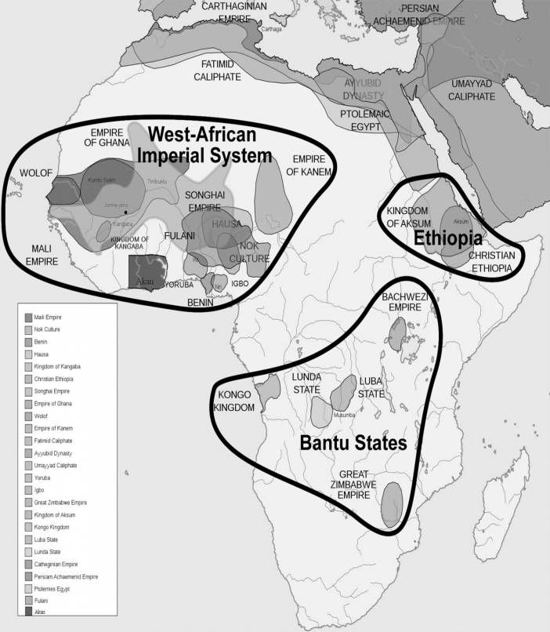
- Identify 3-4 native African Empires or Kingdoms that existed prior to colonialism/imperialism.

- Which European nations imperialized the largest areas of land in Africa?

Document #5: Josiah Strong, an influential American clergyman, wrote the following argument for expansion in 1897.
Within the human species, nations are locked in a struggle for survival. Everywhere, civilized nations are supplanting barbarous nations. Advanced civilization, obviously, has inherited valuable traits from its ancestors. Underdeveloped cultures, except in hostile climates, will soon die off. Therefore, natural order obligates powerful, civilized nations to appropriate the limited resources of the weak. The time is coming when the pressure of population will. . . force the final competition of races.
- Josiah is arguing for expansion using what theory/idea to support his reason to imperialize/colonialize? Provide proof from the passage to support your answer.

- Write a ½ page to full page summary explaining why nations in Europe began to imperialize other areas/places of the world. Be sure to discuss in depth social Darwinism, national security and missionary reasons for imperialism. Cite a piece of evidence from your power point notes, handout #4, or videos you have watched.
Example of citing: Many European nations began to imperialize due to their need for natural resources. According to the map found in power point MT2 lt3, European nations took over many areas of Africa to take their iron, cotton and land to use to support their industries.
Example of citing: Many European nations began to imperialize due to their need for markets to sell their finished products according to MT2 LT3 handout #4, paragraph #4.
______________________________________________________________________________________________________________________________________________________________________________________________________________________________________________________________________________________________________________________________________________________________________________________________________________________________________________________________________________________________________________________________________________________________________________________________________________________________________________________________________________________________________________________________________________________________________________________________________________________________________________________________________________________________________________________________________________________________________________________________________________________________________________________________________________________________________________________________________________________________________________________________________________________________________________________________________________________________________________________________________________________________________________________________________________________________________________________________________________________________________________________________________________________________________________________________________________________________________________________________________________________________________________________________________________________________________________________________________________________________________________________________________________________________________________________________________________________________________________________________________________________________________________________________________________________________________________________________________________________________________________________________________________________________________________________________________________________________________________________________________________________________________________________________________________________________________________________________________________________________________________________________________________________________________________________________________________________________________________________________________________________________________________________________________________________

