World History
Measurement Topic 3: The Causes and Effects of WW1
Level 3: Learn it, study it, and then test it
Learning Target # 1: Reasons nations entered the war (WW1)
Directions:
1st- Number the paragraphs
2nd - Independently read the passage, and circle words you don’t know. Predict the meaning of the words.
3rd- Read the passage a second time with a partner, highlight information and write side notes.
4th- Answer the questions on the back in complete sentences.

There are five main reasons World War I occurred. Militarism, alliances, racial tensions, nationalism and an assassination were all the leading causes of WWI.
During the early 1900’s nations began to practice militarism. Militarism is when a nation aggressively builds up large armies and navies. Nations actively recruit more soldiers, build up their defenses and weapons. Military leaders created plans to quickly mobilize/organize their armies in case of war. Under militarism, nations created plans of action on how to attack certain nations or how to defend from attacks. Once one nation began building up their military other nations felt threatened and began building up their military in response. This led to many, many nations with large militaries. Something that also worried England was that Germany had begun building up its navy. England saw this as a threat, since Germany would most likely be attacking England if a war broke out. These factors made it seem like all these countries had guns pointed at each other just waiting for one nation to mess up so someone could pull the trigger.
Alliances also began to be formed in the late 1800’s and early 1900’s. Alliances are formed when nations create an agreement to support each other (especially for protection). The alliance would provide money or supplies and support in times of war. Two main alliances were established between the main nations. The Triple Entente was the first alliance created between Britain, France and Russia. The second main alliance, the Triple Alliance, was between Germany, Austria-Hungry and Italy. As each country practice militarism and joined alliances, it gave each nation false hope that each side was stronger than the other, therefore they were itching to go to war to prove this point.
Other issues also led to WWI such as racial tensions. Europe is made up of many different ethnic and racial groups. Many of these groups do not get along with each other. Issues at times arouse over control of land and treatment (how other groups were treated, or discriminated against). Smaller nations such as Serbia, Romania and Bulgaria, (they are known as the Balkins) were always being attacked and imperialized by larger nations such as Russia or Austria-Hungary and they did not like the idea of being taken over which caused the smaller nations to rebelled against the larger nations who controlled them, but most of the time they lost, resulting in feelings of resentment and a need to constantly want to fight.
Another feeling also played a role in WWI; nationalism. Nationalism is the feeling of superiority towards other countries or the belief that one nation and its people are greater than all other nations. With militarism, and alliances nations felt that they were superior to other nations and were willing to test this theory with a war. These nations felt that if they won a war, their idea of nationalism would forever be proven correct.
As a result of the buildup of militaries, alliances, building of racial tensions and the feelings of nationalism, Europe was a bomb just waiting to go off. The event that sparked the beginning of WWI took place on June 28, 1914 when Archduke Francis Ferdinand (heir to the throne of Austria-Hungary) and his wife were assassinated by a Serbian terrorist. Austria-Hungary wanted to declare war on Serbia but Austria-Hungary was scared of Russia, Serbia’s ally would interfere, so Austria-Hungary asked Germany if Russia jumped in, if Germany would support Austria-Hungary. Germany agreed to support Austria-Hungary, so on July 28, 1914 Austria- Hungry declared war on Serbia.
At this point there were only two countries at war, Austria-Hungry and Serbia, however when Russia began mobilizing its army, Germany so this as a threat and on August 1, 1914 it declared war on Russia. Since France was also in an alliance with Russia and Germany’s war plan was to attack on both sides of its border (France and Russia at the same time), Germany also declared war on France on August 3, 1914. Since England was an ally to Russia and France in the Triple Entente Alliance, England declared war on Germany on August 4, 1914.
By August 4, 1914, England, France and Russia (the Triple Entente alliance) were at war with Austria-Hungary, Germany and Italy, (the Triple Alliance).

Answer the following questions with complete sentences.
- List the reason WWI started.

- How did militarism help start WWI?

- What were the names of the alliances and who was part of the alliances?

- How did the alliances pull the nations into war after the assassination of Archduke Ferdinand?

- How did nationalism help cause WWI?

- What event ignited/sparked WWI?

- Who declared war on whom?

World History
Measurement Topic 2: Industrial Expansion & Imperialism

Learning target #1: What caused WW1?

Directions: The following questions are based on the accompanying documents/graphs/maps/quotes. As you read and analyze (think about) each document/graph/map/quote be sure to:
^{1nd} - Independently read the chart, passage, and/or map
2nd- Circle words you don’t know. Predict or find the meaning of the words.
3rd- Read the chart, passage and/or map a second time with a partner, highlight information and write side notes.
4th- Answer the questions in complete sentences.

Document 1
This chart provides information on the increasing amounts of money spent on armaments (arms/guns) from 1970 through 1914.
Expenditures of the Great European Powers on Armaments
 | 1870 | 1890 | 1910 | 1914
Great Britain | $3.54 | $3.84 | $7.29 | $8.23
France | 2.92 | 4.66 | 6.47 | 7.07
Russia | 1.28 | 1.26 | 2.32 | 3.44
Germany | 1.28 | 2.80 | 4.06 | 8.19
Austria-Hungary | 1.08 | 1.50 | 1.68 | 3.10
Italy | 1.38 | 2.52 | 3.36 | 3.16

- According to the chart which three nations/countries increased the amount of money spent on weapons/arms? ____________________________________________________________________________________________________________________________________________________________________________________________________________________________________________________________

- How did this increase in spending intensify the chance of war?
________________________________________________________________________________________________________________________________________________________________________________________________________________________________________________________________________________________________________________________________________________________________________________________________________________________________________________________________________________________________________________________

Document 2
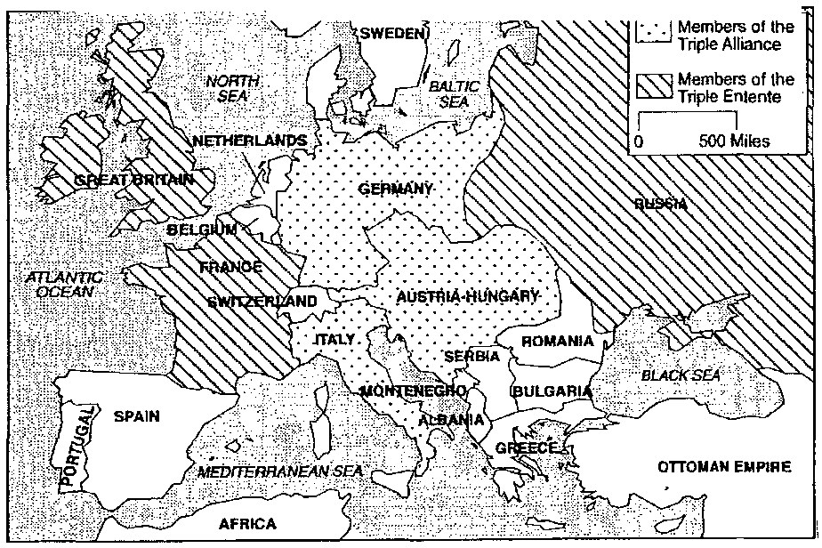
This map of Europe on the eve of World War I shows the alliance system.

- According to the map, who were the members of each alliance system? ____________________________________________________________________________________________________________________________________________________________________________________________________________________________________________________________
- How did this system of alliances contribute to the outbreak of World War I? ____________________________________________________________________________________________________________________________________________________________________________________________________________________________________________________________________________________________________________________________________________________________________________________________________________________________________
Document 3
In his book, Origins of the World War, Sidney Bradshaw Fay stated his position on the causes of World War I.
Nevertheless, a European war broke out. Why? Because in each country (of Europe) political and military leaders did certain things which lead to the mobilization of their armies for war and finally the declarations of war, or these leaders failed to do certain things which might have prevented the war. In this sense, all the European countries in greater or lesser degree were responsible for the outbreak of World War I.
Origins of the World War by Sidney Bradshaw Fay
- According to Fay, who was responsible for the outbreak of World War I? ____________________________________________________________________________________
- What evidence does Fay use to support his claim? ____________________________________________________________________________________________________________________________________________________________________________________________________________________________________________________________________________________________________________________________________________________________________________________________________________________________________

Document 4
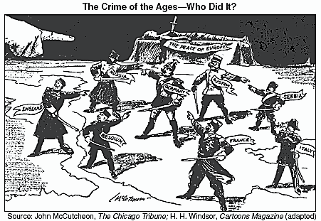
Cartoon A
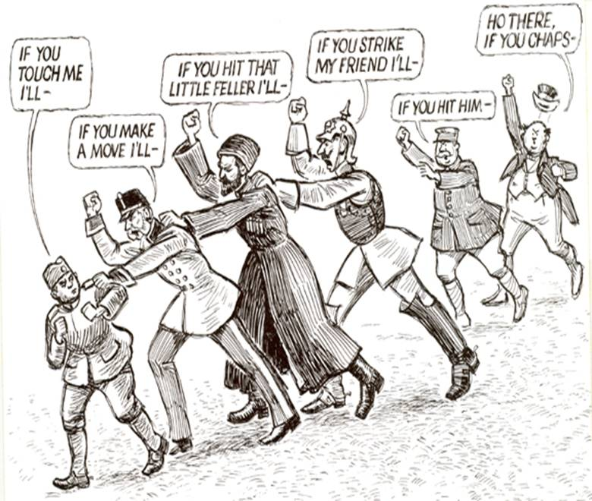
Cartoon B
- What are the European counties doing in cartoon A?
________________________________________________________________________________________________________________________________________________________________________
- What are the European countries doing in cartoon B? ______________________________________________________________________________________________________________________________________________________________________________________
- According to cartoon A, who is to blame for the war? ________________________________________________
- According to cartoon b, who is to blame for the war? ________________________________________________
- In cartoon A, the title is the crime of the century. According to cartoon A, what is the crime of the century and what is your proof? ___________________________________________________________________________

Using the information from your PowerPoint notes, and handout #1).
Write a one page summary on the three most important causes of WW1. Make sure to explain why those were the three most important. .
*************************Be sure to cite evidence from handout#2!******************************
_______________________________________________________________________________________________________________________________________________________________________________________________________________________________________________________________________________________________________________________________________________________________________________________________________________________________________________________________________________________________________________________________________________________________________________________________________________________________________________________________________________________________________________________________________________________________________________________________________________________________________________________________________________________________________________________________________________________________________________________________________________________________________________________________________________________________________________________________________________________________________________________________________________________________________________________________________________________________________________________________________________________________________________________________________________________________________________________________________________________________________________________________________________________________________________________________________________________________________________________________________________________________________________________________________________________________________________________________________________________________________________________________________________________________________________________________________________________________________________________________________________________________________________________________________________________________________________________________________________________________________________________________________________________________________________________________________________________________________________________________________________________________________________________________________________________________________________________________________________________________________________________________________________________________________________________________________________________________________________________________________________________________________________________________________________

