World History
Measurement Topic 3: The Causes and Effects of WW1
Learning Target # 4: What were the effects of WW1 and the effects of the Treaties on; nation’s borders, movement of people, and the economy
Directions:
1st- Number the paragraphs
2nd - Independently read the passage, and circle words you don’t know. Predict the meaning of the words.
3rd- Read the passage a second time with a partner, highlight information and write side notes.
4th- Answer the questions on the back in complete sentences.

World War I shook the economic and political foundations of Europe. The war left nearly every major nation bankrupt and, after four years of total war, entire generations of young men were erased. Nations were left with the task of rebuilding nations torn apart. To make matters worse, the world fell into a deep economic depression. This depression caused large amounts of people to be unemployed, homeless, and starving all over the world. All nations were affected.
After World War 1, Germany’s empire was eliminated and a new government was created called the Weimer Republic. This new government was set up to give the people control over their government. There was a chancellor (president), a congress (parliament) and the people voting to make decisions. This government probably would have been successful had the economic depression not happened and the treaty of Versailles not been so harsh towards Germany. Due to the Treaty, Germany was left with no colonies to gain natural resources and cheap labor, very few working factories and mines due to the war and with huge war time restitutions (payments) Germany was broke, and penniless. These issues would lead the German citizens to resent the Weimer Republic, since they felt it was weak and look to other leaders to help provide a solution to all their issues
The many treaties following World War 1 also created new nations formed from the land taken from the central powers (Germany, Austria-Hungary, and the Ottoman Empire). When Russia had left the war, it had signed over land to Germany. Under the Treaty of Versailles any land gained during the war was lost to Germany. This allowed Poland, Estonia, Finland, and Latvia to be created (new nations). Austria-Hungary was split up to create two separate nations and land was also taken from them to create Czechoslovakia, Yugoslavia and a bigger Romania. The Ottoman Empire was also demolished and the land taken from it was turned into Turkey, Syria, Palestine, Jordan, Iraq and Kuwait. Furthermore all colonies of the central powers were also taken from them and those nations started on the path to independence.
The League of Nations, the peace keeping organization created following WW1, was the group that determined what nations were to be created, what the border for those nations would look like as well as what to do with the colonies taken. The League of Nations leaders, England and France, determined that they would create a system to “watch over” the new nations and colonies. This system was called the Mandate system. England and France would be “in-charge” of these new nations to help them get on their feet before allowing them to be fully independent.
World War1 truly was a world war. Every nation felt the effects of the war. Most nations lost countless men, and were left impoverished. Germany had a new government however their situation did not allow the new government to succeed. New nations were created and colonies were stripped of their previous owner. No part of the world was unaffected by the war.

Answer the following questions in complete questions.
- How did WW1 affect the lives of young men?
- How did WW1 affect the economies (money) of the world’s nations?
- What was the name of the new German government after WW1 and what did this government have to deal with?

- How were new nations created after WW1? What new nations were created?

- What new nations were created from the Ottoman empire?

- Explain the mandate system. (Who created it, why it was created and what it did)

Directions: The following questions are based on the accompanying documents/graphs/maps/quotes. As you read and analyze (think about) each document/graph/map/quote be sure to:
^{1nd} - Independently read the chart, passage, and/or map.
2nd- Circle words you don’t know. Predict or find the meaning of the words.
3rd- Read the chart, passage and/or map a second time with a partner, highlight information and write side notes.
4th- Answer the questions in complete sentences.
Document 1
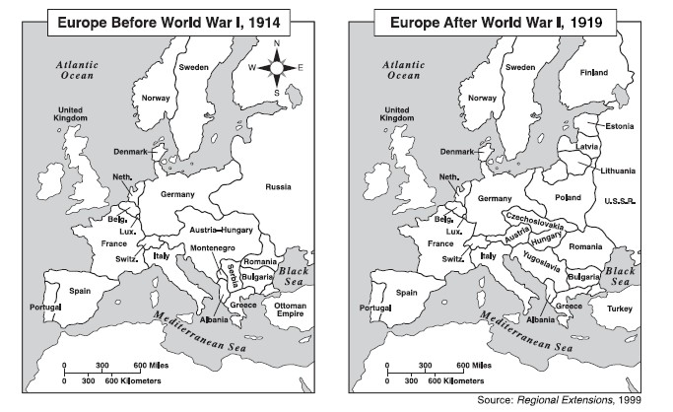
- List the countries and empires that were part of Europe in 1914 that no longer existed in 1919.

- List all the new countries displayed on the 1919 map that were not present during 1914.

- Make two column chart, one titled “gained” and the other titled “lost”. List, under the appropriate columns, those countries that gained or lost territory from 1914 to 1919.

Document 2
Picture A Picture B
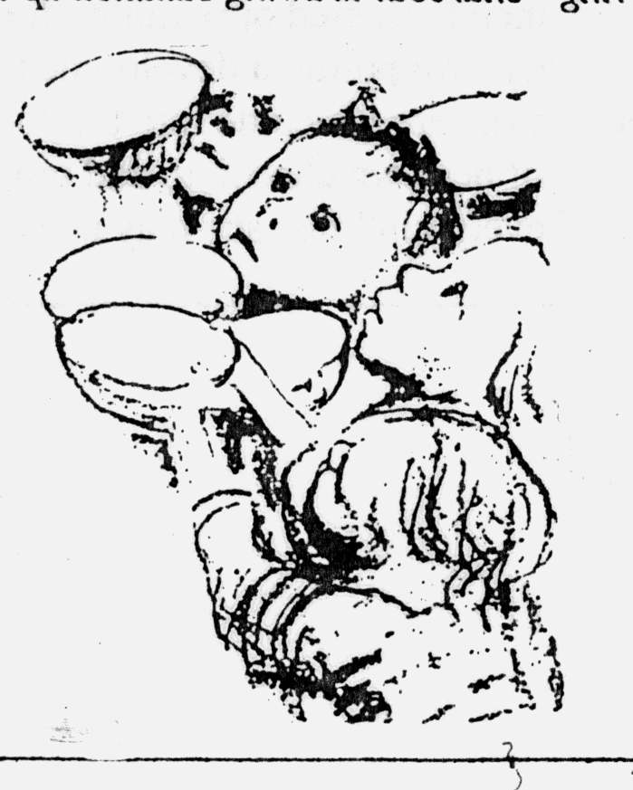
- 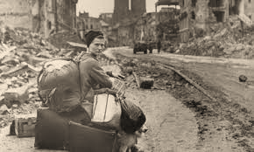
German children are starving A homeless German woman sits in ruins. Photograph: John Florea/Time Life

- What do the pictures illustrate was happening in Germany following WW1? (Details!!!)

Document #3
Passage from the Global Effect of World War 1 by Steven Mintz
World War I killed more than 9 million soldiers, sailors, and pilots and another 5 million civilians. It involved more countries, 28, than any other war and cost more money, $186 billion in direct costs and another $151 billion in indirect costs, than any previous war in history. In a single day at the Battle of the Somme in 1916, 100,000 British troops plodded across no man's land into steady machine-gun fire from German trenches a few yards away. Some 60,000 were killed or wounded. At the end of the battle, 419,654 British men were killed, missing, or wounded. WW1 left at least 7 million men permanently disabled.

- According to document #3, The global effect of WW1, what happened at the Battle of Somme?

- According to document #3, The global effect of WW1, how many counties were involved in the war and what was the total cost of the war?

Document #4

Passage from Economic, Social & Political Consequences of the Great War found @Education Portal
Hyperinflation and unemployment in Weimar Germany were staggering. Reichsmarks, the German currency, became so devalued, that it took wheelbarrows full of money to buy basic items, such as a loaf of bread. One famous photograph shows children flying a kite made out of reichsmarks sewn together.

- According to the passage Economic, Social & Political Consequences of the Great War, why did German citizens need wheelbarrows full of money?

Document #5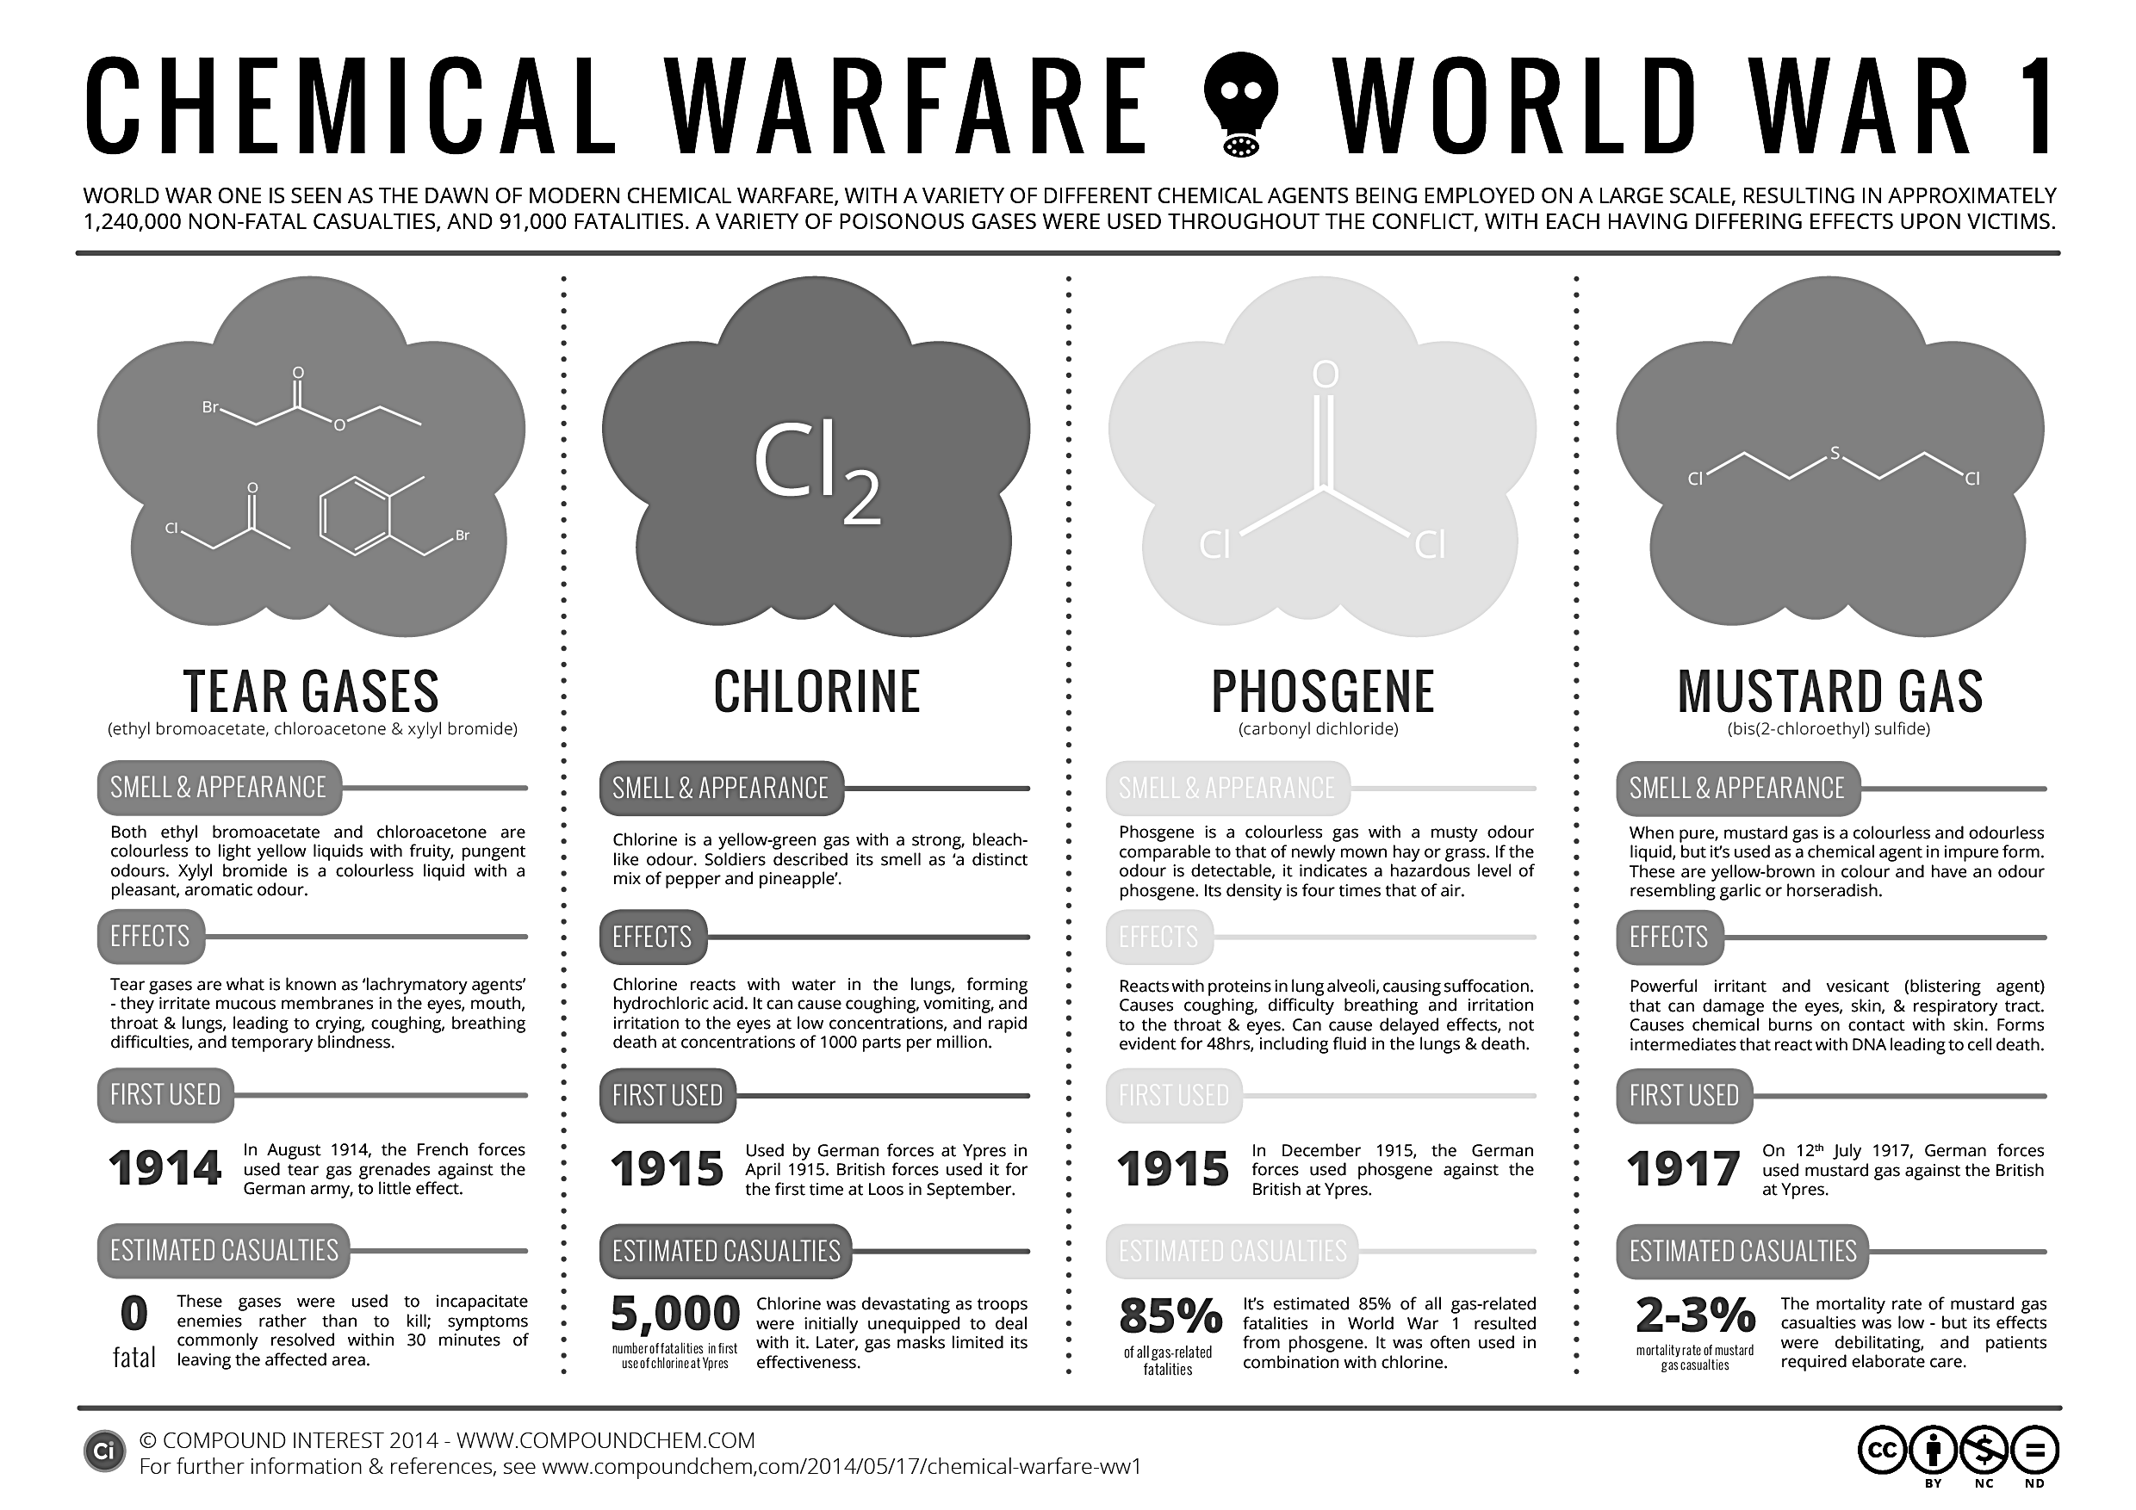
- Based on the information above which gas do you feel would have been the most deadly, effective for a war AND why do you believe this (proof your reason with information from chart)?

Using the information from your PowerPoint notes, handout #4.
Prompt: Write a one page summary about the border changes that took place following WW1. (Gained or lost territory, empires dissolved, new nations created) as well as the effects WW1 had on the people and nations following the end of the war and the treaty agreements.
*************************Be sure to cite evidence from handout#4!******************************
______________________________________________________________________________________________________________________________________________________________________________________________________________________________________________________________________________________________________________________________________________________________________________________________________________________________________________________________________________________________________________________________________________________________________________________________________________________________________________________________________________________________________________________________________________________________________________________________________________________________________________________________________________________________________________________________________________________________________________________________________________________________________________________________________________________________________________________________________________________________________________________________________________________________________________________________________________________________________________________________________________________________________________________________________________________________________________________________________________________________________________________________________________________________________________________________________________________________________________________________________________________________________________________________________________________________________________________________________________________________________________________________________________________________________________________________________________________________________________________________________________________________________________________________________________________________________________________________________________________________________________________________________________________________________________________________________________________________________________________________________________________________________________________________________________________________________________________________________________________________________________________________________________________________________________________________________________________________________________________________________________________________________________________________________________________________________________________________________________________________________________________________________________________________________________________________________________________________________________________________________________________________________________________________________________________________________________________________________________________________

