World History
Mt3- World War I
Level 3 Project

Due date: February 23, 2017 @3:45 on Google Classroom
MT3 Project for Level 3
Requirements for power point:
*10 Slides total
*4 citations
-Only 2 from in class notes or handouts
-2 additional from outside research (your own research)
* What should be in your presentation?
1st-Reasons for WW1
2nd-Why Russia left WW1, USA joined WW1 and how each decision affected WW1.
3rd-Treaty of Versailles and Wilson’s 14 points
4th-Research (your own research)
Period 2- Major leaders of WW1- Austria Hungary (Emperor Franz Joseph I), Germany (Kaiser Wilhelm II), France
George Clemenceau, USA (Woodrow Wilson), England (Winston Churchill), Russia (Tsar Nicholas II, V. Lenin)

Period 3- Research how trench warfare shaped soldiers’ daily life during World War I. Describe the conditions in
Trenches and then explain how trench warfare affected the lives of soldiers.

Period 4- Research the life of women during WW1. Identify how women lives were changed, how they affected
WW1, what roles they played, and identify specific women and their contributions to the war.

Period 5-Food Rationing during WW1 around the world. Why food rationing was needed/started? What foods
were rationed? What nations participated in rationing? How was it organized?

Period 7- Research the impact the new weapons had on World War I. (poison gas, submarines, airplanes, tanks and
artillery shells) Research how the weapons changed the strategy of warfare. What effects did these new
types of war weapons have on war?

Requirements for each different type of project
Power point – 10 slides all together---Must have a title page, 8 slides of information & one picture on each slide, and a work cited page with 4 citations
Research paper – Must be 3 full pages typed and have a work cited page with 3 citations
Brochure – Must have title page, inside information laid out in an organized fashion, have pictures/graphs and have 3 citations on the back
Newsletter- Front and back, must have 3-4 articles and pictures and 3 citations on the back page
Or any other type of evidence that has been approved by Ms. Torres

Due date: February 23, 2017 @3:45 on Google Classroom
Due date Protocol
If you need an extension: You need to notify Ms. Torres two days in advance.
If project is turned in late: Any student that does not complete the mt project at level 3 proficiency by the due date will complete the 5 page in class essay for the MT in place of the project and your life skills grade will be affected.
Resources: Information regarding MT1: www.torreslhs.weebly.com
How to cite: http://www.easybib.com

Assessment Rubric for PowerPoint Presentations

 | Exemplary 3 | Developing 2 | Beginning 1
Organization | Information presented in logical, interesting sequence | Information in logical sequence at times. | Difficult to follow presentation--student jumps around
Subject Knowledge | Demonstrates full knowledge by answering all learning targets with explanations and elaborations | At ease with expected answers to questions but does not elaborate, go into detail. | Unrelated information and project does not address questions on the prompt
Graphics | Explain and reinforce screen text and presentation | At times is related to text and presentation | Rarely uses graphics that support text and presentation
Notes for how to cite:
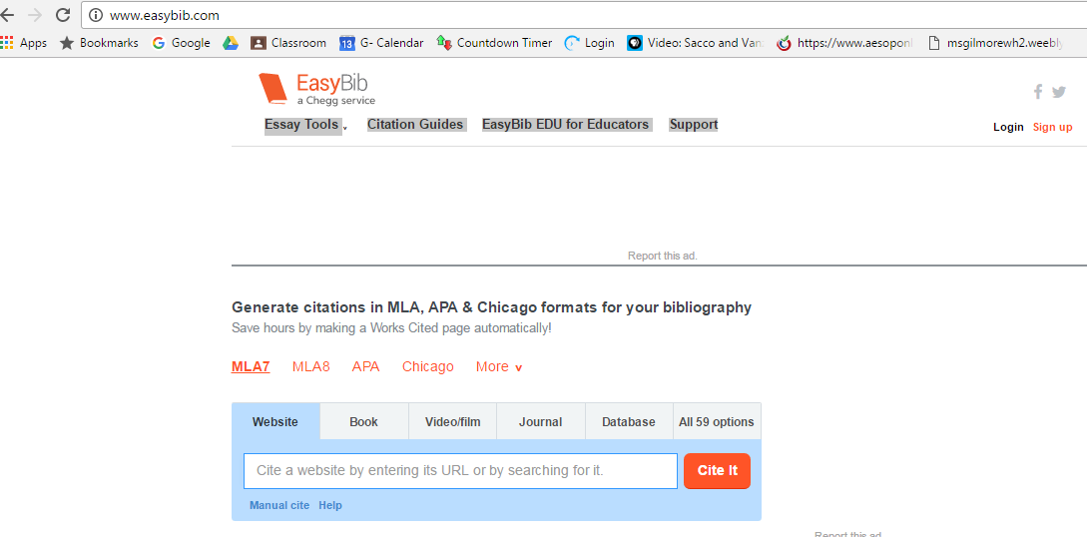
Examples:
If you use a book:
Spielvogel, Jackson S. "Chapter 4 Section 4." World History - California Edition: Modern times. S.l.: Glencoe Mcgraw-Hill Schoo, 2006. 75-78. Print.
If you use a website:
History.com Staff. "Spanish American War." History.com. A&E Television Networks, 2010. Web. 07 Oct. 2016.
If you use my handouts:
Torres, Christina, Ms. MT1: The Development of Modern Political Thought LT#2 Who Were Some Important Leaders of the Enlightenment Movement and What Were Some of Their Ideas? Handout #3. Lindsay CA: LHS, 2016. Print.
Torres, Christina, Ms. MT1: THe Development of Modern Political Thought LT1&2 Explain the Connection between the Magna Carta, English Bill of Rights, Locke's, Montesquieu's and Rousseau's Ideas to the American Revolution and the New American Government. Handout #4. Lindsay CA: LHS, 2016. Print.

