World History
Measurement Topic 4: The Causes and Effects of WW2
Learning Target #2: Explain what Japan, Germany and Italy did to expand their empires.
Learning target #3: Understand why European leaders choose to appease the totalitarian leaders prior to the outbreak of WW2.
Understand why the USA choose nonintervention/isolationism prior to WW2
Directions:
1st- Number the paragraphs
2nd - Independently read the passage, and circle words you don’t know. Predict the meaning of the words.
3rd- Read the passage a second time with a partner, highlight information and write side notes.
4th- Answer the questions on the back in complete sentences.

After world war one some nations began the process of rebuilding their nations to help their people, while other nations began rebuilding to become dominate powers in the world. Italy, Japan and Germany all choose to rebuild their nations with the sole purpose of expanding their empires to dominate the world.

Italy
Benito Mussolini sought to create a new Roman Empire by expanding his empire, much like the Romans had. To gain the support of the Italian people he created a new form of government called Fascism. Fascism is an extreme form of nationalism. Mussolini told the Italian people that they were the best of the best and that they had to support the Italian government in order for a new “Roman Empire” to be successful. He started building his Empire by invading and taking over other nations. His first conquest involved Ethiopia in 1935. Ethiopia was the only independent nations in Africa. Expanding his empire, Mussolini found, was not as easy as he had expected. It took him 7 months to full gain control of Ethiopia. He went on to also invade Albania in 1939. The League of Nations, the peace keeping body for the world, did not do anything to punish nor dissuade Mussolini from creating his new “Roman Empire”. The League of Nations appeased Mussolini by allowing him to keep Ethiopia and Albania for a small fine ($). Soon he joined forces with Hitler in Germany in hopes of expanding his empire further.

Germany
Adolf Hitler slowly gained control of Germany after WW1. He believed that the Germans were a “master race” or a superior race to other races. He wanted to create a master Aryan race, which were only blue eyed, blonde haired people. He started this control over the people in Germany by holding rallies and giving speeches to the people telling them if they followed him, Germany would be the strongest nation. Once he gained control of Germany his master plan started. He created an air force, a military draft to make military service mandatory, which also enlarged the army by five times. At this point France and Great Britain told Germany to stop their aggressive steps. Hitler promised he would stop. However soon after this first warning Germany entered the demilitarize area between Germany and France known as the Rhineland. This area was created to protect France from an invasion from Germany. France was upset and wanted Great Britain to support them in attacking Germany for violating the Treaty of Versailles. Great Britain felt that it was “ok” for Germany to “play” in their own back yard. Again they warned Hitler to not go any further. These actions by Great Britain to ignore Germany’s behavior and only gain promises to not precede any further with aggressive behavior became known as appeasement. The European nations agreed to the demands in order to maintain peace.
By 1937 Germany was once again a world power. Hitler felt no threat from any nation. In March of 1938, Hitler invaded Austria then on September 15th 1938 he demanded Czechoslovakia give him the “Sudetenland” in northern Czechoslovakia. These two events made the world realize they needed to have a meeting to discuss how to handle Hitler.

Munich Conference
On September 30th 1938 the major leaders, Adolf Hitler, Benito Mussolini, French Premier Eduardo Daladier, and British Prime Minister Neville Chamberlain met to discuss Hitler’s demands. The meeting resulted in the signing of the Munich Pact, which sealed the fate of Czechoslovakia, virtually handing it over to Germany in the name of peace. Again the nations used appeasement to keep peace by handing over Czechoslovakia to Hitler. After the conference Hitler was convinced the western democratic nations were weak and would or could do nothing to stop him. By 1939 he took over all of Czechoslovakia and made demands to gain Poland. He also signed a treaty with the Soviet Union in 1939 known as the “Nazi-Soviet Non-Aggression Pact” stating that neither nation would attack the other. The next step Hitler would make to expand his empire would put the entire world at war again.

Japan
Japan felt that they could dominate the entire Asian continent but they needed resources since they were a small island nation with limited resources. In September of 1931, Japan took over Manchuria for their natural resources. Japan claimed they took it over because China had attacked them, when in reality, Japan pretended to be attacked in order to take over Manchuria. China’s leader Chiang Kai-shek attempted to appease Japan since he had his own issues to deal with. (Mainly communist trying to take over China.) The Japanese imperial army continued to attack various Chinese cities for the next six years with China doing very little, hoping to soon have peace with Japan. In December of 1937 the Japanese captured the Chinese capital of Nanking. The brutality of the Japanese soldiers towards the Chinese became known as the Rape of Nanking. No one, old, young, male or female was speared from torture or death. The USA did agree with Japans plans of expanding so they stopped selling important resources to Japan such as steel and fuel. The United States also supplied the Chinese government with weapons to help fight the spread of the Japanese. This angered Japan. Japan went on to take over Indonesia and many other islands in the Pacific (Hint closer to Hawaii) in their quest to take over Asia with little interference from the League of Nations, China or the United States.

United States Non-Intervention
The American people did not want to be involved in another war. The United States had dealt with a severe economic depression following WW1, therefore the United States wanted to stay out of the issues that were taking place in Europe with Hitler and Mussolini. The United States choose to follow a plan of isolationism, not getting involved in any of Europe’s issues. After WW1 the USA choose not to be tied/united to other nations, consequently, attempted to appease everyone by creating laws called neutrality acts to keep the United States neutral. Because the United States failed to get involved and even created laws to prevent it from being involved, both Germany and Japan saw the United States as weak.

WW2 starts.
Hitler did not keep his promise to stop invading nations and on September 1, 1939 Hitler invaded Poland because of his pact with the Soviet Union/Russia he did not fear them. As a result of Hitler’s invasion of Poland, on September 3, 1939 Great Britain and France declared war on Germany, and Germany quickly puts its air force into action and begins bombing England daily. Germany also invaded France and by June 1940 Germany controlled ¾ of France. Hitler did not stop there, June 22 1941 Germany went against the “Nazi-Soviet Non-Aggression Pact” he had created with the Soviet Union when he invaded the Soviet Union/Russia.
As Hitler was taking over all of Europe, Japan made a bold move. Japan felt it needed to take the USA out of the picture so, on December 7, 1941 Japanese aircraft attacked the U.S. naval base at Pearl Harbor, Hawaii. On the same day Japan attacked the Philippines, Malaya and other islands in the Pacific Ocean. By December 8th the USA declared war on Japan and its ally Germany. World War 2 was in full swing.
Answer the following questions with complete sentences.
- What did Mussolini do to expand his empire?

- What did Adolf Hitler do to expand his empire?

- What is appeasement?

- Why did Great Britain attempt to appease Hitler?

- What was the Munich Conference?

- What was the non-aggression pact?

- What was the rape of Nanking?

- Why did the USA take a nonintervention stance to the issue in Europe? Why did the USA follow a policy of isolationism?

Directions: The following questions are based on the accompanying documents/graphs/maps/quotes. As you read and analyze (think about) each document/graph/map/quote be sure to:
^{1nd} - Independently read the chart, passage, and/or map
2nd- Circle words you don’t know. Predict or find the meaning of the words.
3rd- Read the chart, passage and/or map a second time with a partner, highlight information and write side notes.
4th- Answer the questions in complete sentences.
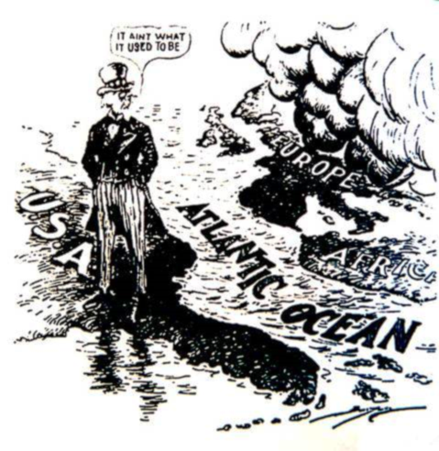
Document 1
“It Ain’t What it Used to Be”
During the late 1930’s, Americans were divided about becoming involved in “Europe’s quarrels”. Some people felt that the United States should be more involved in the problems occurring across the Atlantic, however isolationist believed the USA should stay completely out of the other nation’s affairs. The idea that America and Europe were two separate worlds divided by the Atlantic ocean was held by most Americans.

- What does Uncle Sam’s (the guy who resents the USA) turning his back on Europe show about American attitudes regarding the events/issues in Europe?
________________________________________________________________________________________________________________________________________________________________________________________________________________________________________________________________________________________________________________________________________________________________________________________________________________________________
- What USA policy/plan does the cartoon imply?
____________________________________________________________________________________________________________________________________________________________________________________

Document 2
As German aggression continued, a meeting was held in 1938. Great Britain, France and Italy met with Hitler to discuss his demand for the Sudetenland, a section of Czechoslovakia. The following is a radio broadcast which describes what happened at the meeting.
It took the Big four just five hours and twenty-five minutes here in Munich today to dispel the clouds of war and come to an agreement over the partition of Czechoslovakia. There is to be No European war…the price of peace is… the ceding by Czechoslovakia of the Sudeten territory to Herr Hitler’s Germany. The German Fuhrer gets what he wanted…His waiting ten short days has saved Europe from a World war…most of the people of Europe are happy that they won’t have to go marching off to war…Probably only the Czechs….are not happy but there seems very little that they can do about it in face of all the might and power. Source: William shirer, CBS broadcast, 1938
- What happened at the Munich conference to prevent another world war?

- Which nation was not going to be happy and why?

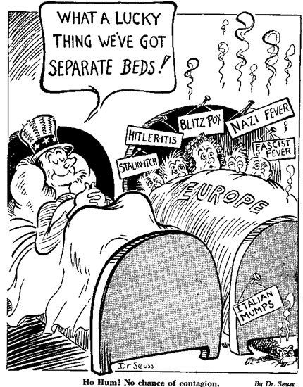
Document 3
The following political cartoon was drawn by Dr. Suess.
- Who does the man sleeping alone represent?

- What does the cartoon represent is going on in Europe?

- Why isn’t the man sleeping alone helping the sick people?
Document 4
After Italy attacked Ethiopia, Haile Selassie, emperor of Ethiopia, asked the League of Nations for help in stopping the invasion. He asked for military sanctions but the League of Nations' response was ineffective. Haile Selassie used these words to the League of Nations:
God and history will remember your judgment. . . . It is us today. It will be you tomorrow.

- Why did Haile Salassie say, “ …us today…you tomorrow.”?

- Why did the League of Nations not respond to the attack on Ethiopia?

Document 5
In this excerpt by Keith Eubank from Origins of World War II, the author argues that the discussion about stopping Hitler prior to 1939 was not an issue for several reasons.
. . . neither the people nor the government of [Britain and France] were conditioned to the idea of war. . . . Before September 1, 1939, Hitler had done nothing that any major power considered dangerous enough to warrant precipitating [starting] a major European war. Nor was there any existing alliance that could have opposed Hitler's massive forces. For Britain sought to appease Hitler [and] the French feared a repetition of the bloody sacrifices of 1914-1918….and the United States rejected all responsibility for Europe.

- Do you agree with the statement, “Before September 1, 1939, Hitler had done nothing that any major power considered dangerous enough to warrant precipitating [starting] a major European war.”? Had Hitler done nothing major?

Using the information from your PowerPoint notes, and handout #2.
Write a summary addressing the following:
- How, why and where the totalitarian leaders expanded their empires.
- Explain why the European nations appeased Japan, Hitler and Mussolini when they expanded their empires. Be sure to give specific examples of appeasement.
- Why the USA wanted to remain neutral/isolationist prior to and at the start of WW2?
*************************Be sure to cite evidence from handout#2!*******************************
________________________________________________________________________________________________________________________________________________________________________________________________________________________________________________________________________________________________________________________________________________________________________________________________________________________________________________________________________________________________________________________________________________________________________________________________________________________________________________________________________________________________________________________________________________________________________________________________________________________________________________________________________________________________________________________________________________________________________________________________________________________________________________________________________________________________________________________________________________________________________________________________________________________________________________________________________________________________________________________________________________________________________________________________________________________________________________________________________________________________________________________________________________________________________________________________________________________________________________________________________________________________________________________________________________________________________________________________________________________________________________________________________________________________________________________________________________________________________________________________________________________________________________________________________________________________________________________________________________________________________________________________________________________________________________________________________________________________________________________________________________________________________________________________________________________________________________________________________________________________________________________________________________________________________________________________________________________

